**Podcast: Everything you need to know!**

A podcast is an episodic series of some content and it acquires a huge fan base. Various businesses use podcasts for content marketing.

To start the podcast, all you need is to come up with the perfect concept for content development. Then you need to design all the artwork and write every minute detail and description to help with the branding. Then comes the recording and editing of the audio files, and converting them into a perfect format. And finally comes the hosting services to host your podcast and distribute them over to the audience.

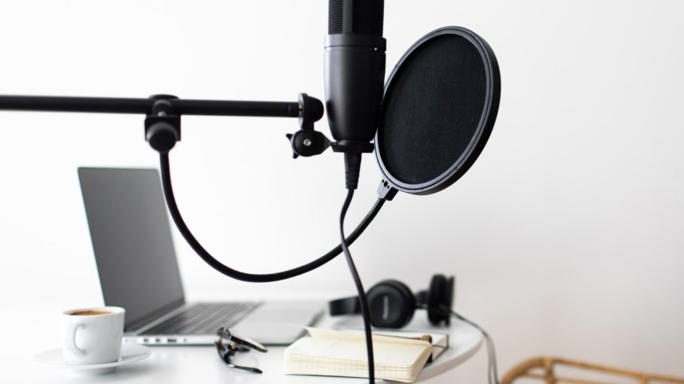

It is a simple technique and does not require much investment or skills to start. Here is all that you might find helpful regarding the same:

***Working of podcast:***

There are two ways available for podcast playing and streaming. RSS feed is there to have access to various podcast contents, and the blogs or websites are also used to check the directly embedded contents. The other method to use is by iTunes or Pocket Casts. The player loads the RSS feeds and the devices access the contents. These players use syncing to provide the RSS feeds.

***Why Podcast?***

Content generation and marketing play a crucial role in business branding and marketing practices. Podcasting is another content marketing technique that allows reaching out to a giant audience base. Podcasts have several backlinking and its directories provide a link back to your website that helps to increase the traffic on them. Records state that 30% of the time spent on audio resources is for podcasts. Statistics reveal how various niches sums up to about 21.1 billion hours of listening for the podcasts. There are dozens of categories available for various listeners according to various likings.

Starting a podcast allows marking a unique position in the market and makes it easier to sell the products and services as it ensures being an influencer.

Podcasts are popularly used because they are easily developed and assessed anytime and they do not require any particular medium for posting. They are available on any device including radios, Smartphones, tablets, and any other that increases their fan base. Podcast provides higher engagement and helps to ensure a deeper connection with the audience and build a better relationship to ensure their complete support and admiration. Podcasts are free too.

***Getting Started and the prior understandings for a podcast:***

Getting started with podcasts requires the identification of themes and the category for the content generation. Then comes defining of structure for the podcast and there are various styles like the interview, solo, narrative or storytelling, and hybrid. And the final decision is about the time for the podcast episodes.

After all these decisions, the important next step is the artwork. You need to create an attractive and memorable artwork for podcasts to attract more number of people. You might also hire an expert for designing, but the artwork must be catchy. Then comes the finalizing of the podcast name, and the description generation for the same. The content should be search engine optimized to provide a higher ranking to it.

***Software and Tools required:***

One can also develop a podcast with the use of just their mobile devices. There are applications available like Anchor, Speaker, Opinion, and a few others that can convert the Smartphones into the podcast recorders. However, to make the professional content with higher quality, the following tools and software are a must.

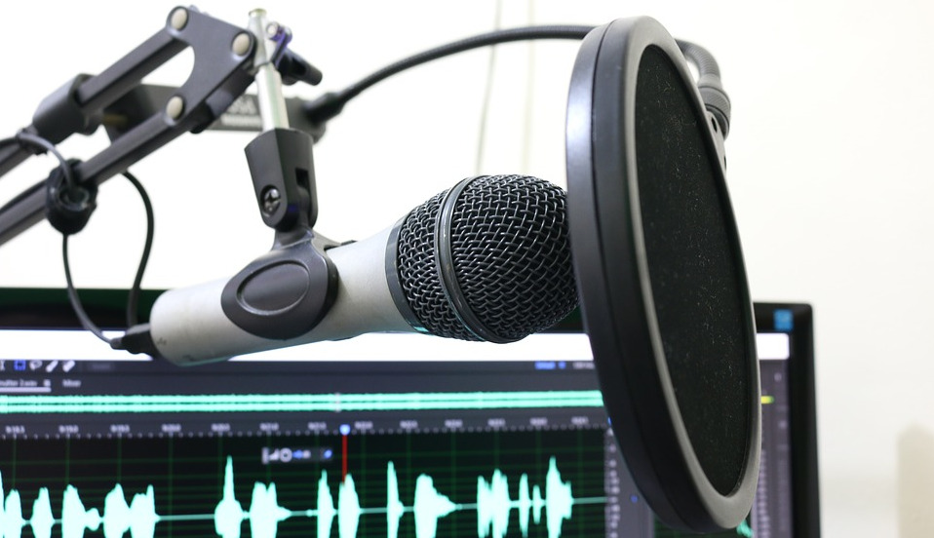

**Microphone**

Every device including the computers and laptops has the USB ports for connecting the microphone externally. Various microphone devices are available too that are plug and playing based and requires no installed drivers. These microphones help to ensure better quality for the podcast and clear audio that ensures more ratings for the content. These devices also come with built-in microphones but using the external one that is specially meant for quality enhancement is a preferable choice.

**Audio recording software**

Softwares are available for PC and laptops that help to effectively record the audio using the microphones and save them as '.MP3' files. The software also allows editing of the recording and helps with the modulations too. Softwares are available like Adobe Audition at 20.99 USD per month, and this is available for both Windows and macOS. Free Softwares are there too for both windows and Mac, like Audacity and GarageBand. Several tutorials are also available online on YouTube and Google to learn the working of the software and get the best quality content.

**Call recording software**

Podcasts are not only one-way contents like storytelling ones, but they also come like the interview contents or the conversational contents. The new podcast developers with basic setup might require call recording Softwares as they do not require much merging and mixing of the recorded contents and are easy for use. There are various free applications available like uberConference, and paid ones are there too like Pamela and Callnote.

**Accessories for quality enhancement**

Filters are available for using with microphone for noise-free contents and recordings. They are hands-free and easily installable with higher flexibility. Headphones are also a necessity for the two-way conversational contents to get proper listening for every statement.

***Podcast Hosts and streaming services:***

Podcast contents require a separate host with high bandwidth and speeds for downloading and streaming the audio ‘.MP3’ files. Top hosting services like Libsyn and Blubrry start with $5 and $12 per month respectively with unlimited bandwidth. After completing the hosting selection, the host provides an RSS feed containing all the episodes and data and this feed submits to various directories for accessibility by the audience. Directories available for the podcasts are iTunes, SoundCloud, Spotify, YouTube, etc.

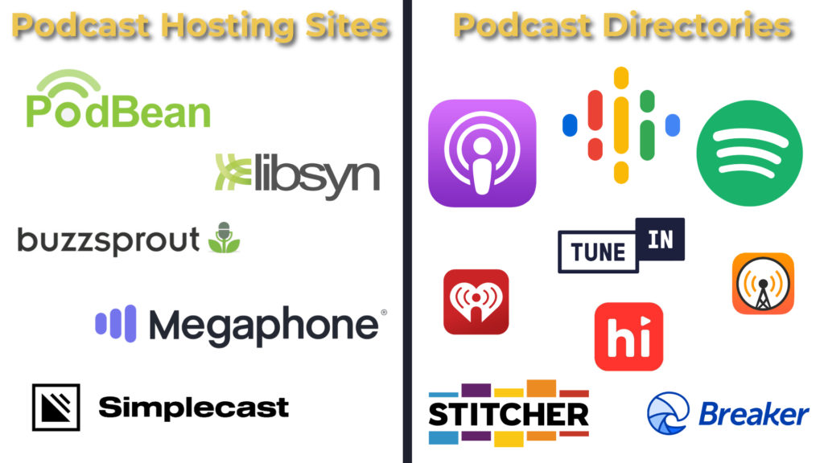

***Launching and growing the podcasts***

iTunes provides a ‘New and Noteworthy’ option that is the best marketing that any new broadcast can get for acquiring the fan-base. Making the podcast an event helps to get attention for the content with the proper landing pages and attractive artwork. One can also attract people by a pre-launch for the main content to generate the audience before-hand.

You can also encourage people to visit your handles and check the podcasts, and you can also provide the rewards to the ones reviewing the contents. A series of podcasts is preferable and consistency with the releases helps to attract the folks.